Product State updates by Trade Server Design

Server Overview

Current Processing - Currently, in SBT, we do not have any support for changing product state by Trade Svr (i.e. by Group). We can change the product state only by Session, which would be for all classes associated with session.

New Approach - We like to add flexibility in changing product state by group as well as by classes. A method will be added in TradingSessionMaintenanceService idl interface. SA GUI will make an appropriate call.
setProductStatesForSessionForGroup

1. Change product state for a group
SAGUI will call setProductStatesForSessionForGroup on TSS by passing one group at a time along with sessionname & newstate. The classes, which would fail with some errors for a group, will be reported back (ErrorCodeResultStructs) as part of this synchronous call. The result struct will have classKey, error description, error code and seq of products that are failed. Internally, TSS will first validate the group. The products of classes assigned to this group will be changed to new state by calling PSS.setProductStateByClassV2(). Before all the BCs are rolled out with this new code, the call on PSS will be made is setProductStateByClass (v1 call)
Facilitator idl method is added to return all the valid groups for all sessions. SAGUI makes a call (getTradingSessionRoutingGroupNames) to TSS.

2. Return descriptive errors for existing calls (deprecating old calls)
As part of this feature, we decided to handle the currently available idl methods better error handling point of view. So that setProductsForSessionV2 and setProductStatesForElementV2 will return GroupErrorCodeResultStructSequence. The struct[] will return failed elements’ groupKey, groupName and ErrorCodeResultStructs.

1. Code changes -
- TradingSessionMaintenanceService
- ProductStateService

2. Script Changes -
- setAllProductStatesForSession (modified to call v2 method & byGroup method)
- setProductStateForTradeServer (modified to call v2 method)
- getServersForSession (new script to get the registered servers for sessionState or productState)

3. DB Changes -
None

4. Config changes -
XML/DTD
– property allBusinessServersRolledOut is added in TradingSessionService xml/dtd. This property, by default is set to false. It needs to be modified to true once all BC’s will be rolled out with new version code of hybrid failover.
- property groupTypeForProductState is added in TradingSessionService xml/dtd. This property, by default is set to 2. (TradeServer type group). This will be helpful in validating the group whether it’s a tradesvr or not.

5. Implementation Plan -
Update documentation.

6. Testing -
Update for all possible scenarios.

7. Operator Procedure -
None

8. Fallback/Failover -
Will be taken care while coding.

9. Rollout -
Both GlobalSvr needs to be rolled out first, then BCs and then SA CAS/GUI.

GUI Overview
The users would like to navigate the classes for setting product states as they are grouped by trade server. The current implementation allows them to navigate them by trading session only.
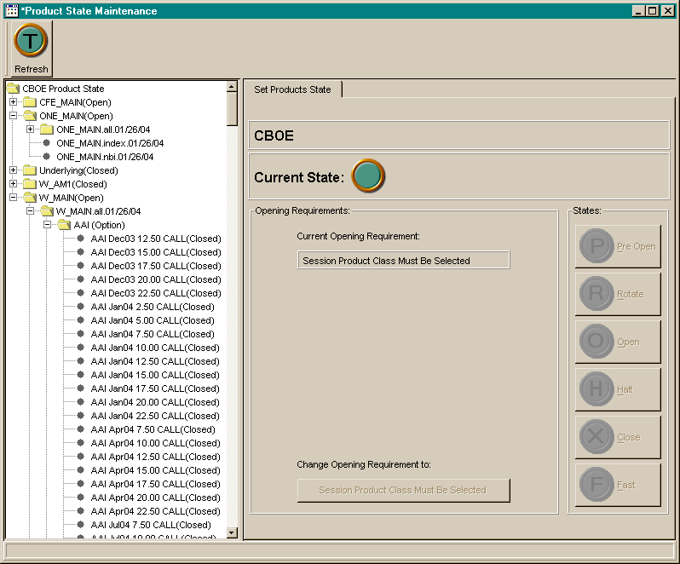

Menu Navigation and Toolbar
We should put a menu bar on the screen and remove the toolbar. I would suggest that the menu look like this:

Products
Change State
Pre-Open
Rotate
Open
Halt
Close
Fast
Change Opening Req.
(text will vary, based on selection)
<separator>
Refresh
<separator>
Close
Edit
Mode
Enable Support Mode

These menu items should all be reusable action objects so that we can represent them as other GUI components as well.

Support Mode
The “Enable Support Mode” menu item should be a checkbox menu item that only shows the check mark when Support Mode is enabled.

When this menu item does not have the check mark, thus Support Mode is not enabled, and it is selected, a dialog will appear with a password prompt. If they enter the correct password, then Support Mode will be enabled and the check mark will be displayed on the menu item.

When this menu item does have the check mark, thus Support Mode is enabled, and it is selected, Support Mode will be disabled and the check mark will not be displayed on the menu item.

See the Product Groups package for some reusable code for the password prompt dialog to enable support mode (SupportModeDialog, SupportModeAction, etc..). We should move these related classes to a more common package within the SAGUI package hierarchy. This will require some refactoring of this code and the product groups usage of it.

Settings Tabs
The current tab should be renamed to Product States.

A new tab should be added for Opening Requirements. The current Opening Requirements panel should be moved to this tab. Lets try to collapse the over abundance of white space in this panel.

A new tab should be added for Sub Groups. This tab will only be displayed when the “By Group” (see below) tree navigation component is active. See “Sub Groups” below for details of what should be on this tab.

Make sure we provide keyboard navigation to select these tabs.

Tree Navigation
The existing tree will be on a new tab named “By Session”. There will be a new tree navigation component to select from, on a new tab named “By Group”. Make sure we provide keyboard navigation to select these tabs. This “By Group” tree will only be enabled if the Support Mode is enabled. The user will be able to open tree nodes for display, but they will not be able to perform any actions on them. The hierarchy of this new “By Group” tree will be as such:
Session 1 (i.e. ONE_MAIN, W_MAIN)
Group Name 1
Class 1 (i.e. AOL, IBM)
Products 1-n
Class 2 (i.e. AOL, IBM)
Products 1-n
Group Name 2
Class 1 (i.e. AOL, IBM)
Products 1-n
Class 2 (i.e. AOL, IBM)
Products 1-n
Session 2 (i.e. ONE_MAIN, W_MAIN)
Group Name 1
Class 1 (i.e. AOL, IBM)
Products 1-n
Class 2 (i.e. AOL, IBM)
Products 1-n
Group Name 2
Class 1 (i.e. AOL, IBM)
Products 1-n
Class 2 (i.e. AOL, IBM)
Products 1-n

See SessionProductTreeModel.getLoadSessionsWorker for the example on how the existing tree is loaded.

Current State Panel
Currently, unless a specific product is selected, this panel does not showing anything. This is due to the fact that we do not implement this state at the class level. Lets change this so that if any node is selected other than a product, this panel shows a count of all the unique product states for all children nodes. Only show counts for which a state does exist.

Currently Selected Panel
The panel that represents the text of the current selection should be removed from the “Product States” tab and be placed outside the tabs so that it is displayed regardless of the selected tab.

Exceptions and Return Types
The new methods to set product states for groups will return structs that contain details about errors on individual classes. We need to show the user these details and possibly highlight the classes.

The existing method to set product states for a class will be replaced with a new one that will also return a struct that contains details about the errors on the first failed individual product. We need to show the user these details and possibly highlight the product.

These methods will still throw exceptions as well for other cases/conditions. We need to continue to handle these as well.

Sub Groups
When a group or any child node of a group is selected in the tree navigation component, this tab will display a tree showing the sub groups hierarchy from PCS. The user will be able to navigate this tree only for informational purposes. Any selection within this tree will not perform any action. See many of the classes in the productGroups package for reuse/refactoring.

